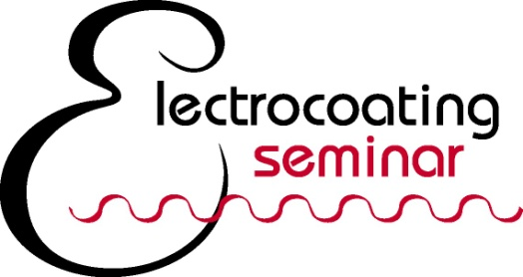
September 26-27, 2017 • Cleveland Airport Marriott, Cleveland, Ohio

June, 2017
Thank you for your interest in becoming an Electrocoating Seminar Sponsor. The sponsorship fee is $300 and includes the following:
- Company name/logo on seminar webpage at www.electrocoat.org
- Recognition in printed registration brochure to over 4,000 industry professionals
Note: Logos must be received by July 6 print deadline.
- Company literature displayed at the networking reception
- Company name on event signage
- Company name announced during the seminar and networking reception
To reserve a sponsorship, please provide the following information:
Contact Name: _________________________________________________________
Telephone Number: __________________Contact Email : _______________
Company Name: _______________________________________________________
Web site to link to:
Please email your company logo in .jpg format to anne@electrocoat.org
Payment Type:
- Check enclosed, payable to: The Electrocoat Association
- Credit Card: call Anne at 800-563-8831 or pay online at www.electrocoat.org
Return form to:
Anne Von Moll
The Electrocoat Association
P.O. Box 541083
Cincinnati, OH 45254
FAX: 513-527-8801
Email: anne@electrocoat.org

Presented by 